**TUGAS MINGGU KETIGA**

**STATISTIKA DESKRIPTIF**



**NAMA : MUKHAMAD IKHSANUDIN**

**NIM : 082011633086**

**S1 SISTEM INFORMASI**

**FAKULTAS SAINS DAN TEKNOLOGI**

**UNIVERSITAS AIRLANGGA**

**2021**

1. generate data sebanyak 100 ribu

MyData <- sample(1:100, 100000, replace =TRUE)

1. kuantil, desil, persentil

* Perintah yang sama dengan argument yang berbeda

Kuartil_A <- quantile(NamaData)

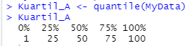

Desil_A <- quantile(NamaData, c(0:10)/10)



Persentil_A <- (NamaData, c(0;100)/100)

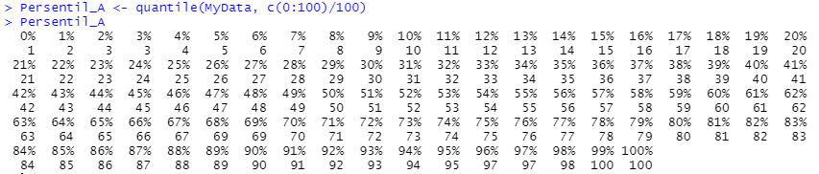

* Perintah beda

kuartil <- function(x){

kuartil.x <- quantile(x, seq(0, 1,0.25))

kuartil.x

}

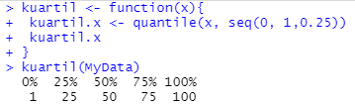

desil <- function(x){

desil.x <- quantile(x, seq(0, 1,0.1))

desil.x

}

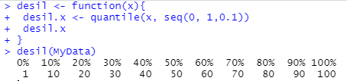

persentil <- function(x){

persentil.x <- quantile(x, seq(0, 1,0.01))

persentil.x

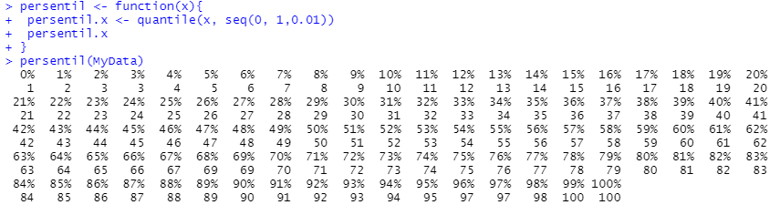}

1. rentang data dan deviasi standard

> max(NamaData) – mix(NamaData)



> sd(NamaData)



1. generate data sebanyak 500 ribu sedemikian membentuk Kemiringan negative 🡪 gunakan histogram

> MyData_1.1 <- c(sample(1:90, 50000, replace = TRUE), sample(90:190, 70000, replace = TRUE), sample(190:300, 120000, replace = TRUE), sample(300:400, 155000, replace = TRUE), sample(400:500, 110000, replace = TRUE))

> hist(MyData_1.1)

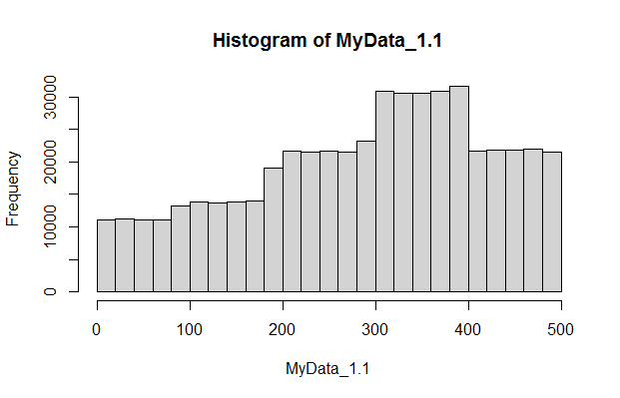

1. generate data sebanyak 500 ribu sedemikian membentuk Kemiringan positive 🡪 gunakan histogram

> MyData_1.2 <- c(sample(1:75, 40000, replace = TRUE), sample(75:125, 85000, replace = TRUE), sample(125:200, 150000, replace = TRUE), sample(200:350, 140000, replace = TRUE), sample(350:500, 85000, replace = TRUE))

> hist(MyData_1.2)

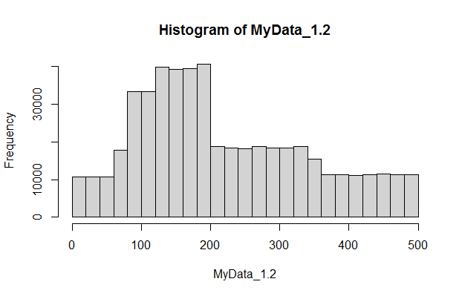

1. generate data sebanyak 500 ribu Keruncingan negative 🡪 gunakan histogram

> MyData_1.3 <- c(sample(1:100, 85000, replace = TRUE), sample(100:200, 100000, replace = TRUE), sample(200:300, 130000, replace = TRUE), sample(300:400, 100000, replace = TRUE), sample(400:500, 85000, replace = TRUE))

> hist(MyData_1.3)

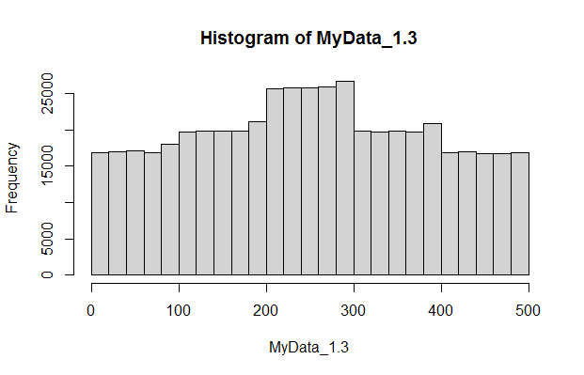

1. generate data sebanyak 500 ribu Keruncingan positive 🡪 gunakan histogram

> MyData_1.4 <- c(sample(1:100, 40000, replace = TRUE), sample(100:210, 60000, replace = TRUE), sample(210:290, 300000, replace = TRUE), sample(290:400, 60000, replace = TRUE), sample(400:500, 40000, replace = TRUE))

> hist(MyData_1.4)

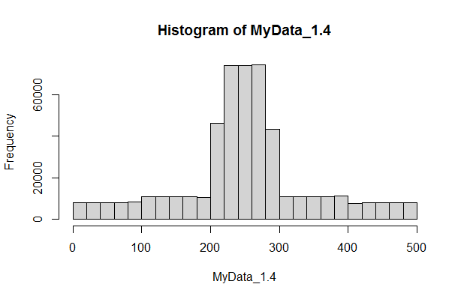

1. untuk no 2 s.d. 5 hitung nilai kemiringan dan keruncingan-nya kemudian jelaskan nilai-nya dan bandingkan dengan gambarnya

* No. 2 (MyData_1.1)

> kemiringan = function(data){

kemiringan = length(data) * (sum(data-mean(data))^3) / ((length(data)-1) * (length(data)-2) * (sd(data))^3)

kemiringan

}

> kemiringan(MyData_1.1)

[1] -7.234902e-34

Kemiringan 🡪 Negatif dan sesuai dengan gambar

* No. 3 (MyData_1.2)

> kemiringan = function(data){

kemiringan = length(data) * (sum(data-mean(data))^3) / ((length(data)-1) * (length(data)-2) * (sd(data))^3)

kemiringan

}

> kemiringan(MyData_1.2)

[1] 2.362199e-33

Kemiringan 🡪 Positif dan sesuai dengan gambar

* No. 4 (MyData_1.3)

> keruncingan = function(data){

+ runcing1 <- (length(data) * (length(data)+1) * (sum((data-mean(data))^4))) / ((length(data)-1) * (length(data)-2) * (length(data)-3) * (sd(data))^4)

+ runcing2 <- 3 * ((length(data)-1)^2) / ((length(data)-2) * (length(data)-3))

+ keruncingan = runcing1-runcing2

+ keruncingan

+ }

> keruncingan(MyData_1.3)

[1] -1.020162

Keruncingan 🡪 Negatif dan sesuai dengan gambar

* No. 5 (MyData_1.4)

> keruncingan = function(data){

+ runcing1 <- (length(data) * (length(data)+1) * (sum((data-mean(data))^4))) / ((length(data)-1) * (length(data)-2) * (length(data)-3) * (sd(data))^4)

+ runcing2 <- 3 * ((length(data)-1)^2) / ((length(data)-2) * (length(data)-3))

+ keruncingan = runcing1-runcing2

+ keruncingan

+ }

> keruncingan(MyData_1.4)

[1] 0.738092

Keruncingan 🡪 Positif dan sesuai dengan gambar

1. generate 10 bilangan kemudian buat bar-plot-nya

> Bil <- sample (1:100, 10, replace = TRUE)

> Bil

[1] 5 70 48 47 67 25 56 8 59 92

> barplot(Bil)

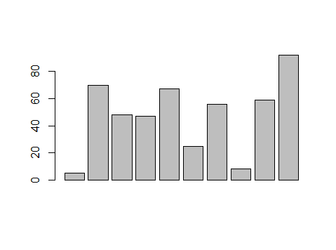

> barplot(sort(Bil))

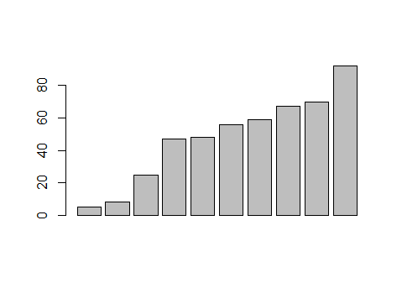

1. generate 1000 data yang memuat outlier dan buat box-plot

> MyData2 <- c(1, sample(50:100, 999, replace = TRUE))

> boxplot(MyData2

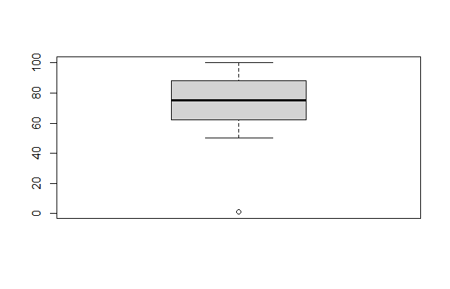

1. generate 1000 data yang tidak ada outlier dan buat box-plot

> MyData3 <- sample(1:1000, 1000, replace = TRUE)

> boxplot(MyData3)

